Preparing Students for External Science Papers
 | 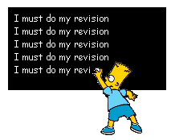 | 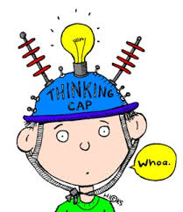

Introduction
Last term I prepared a booklet containing ten literacy strategies. This term I thought it might be useful to have some strategies to help students to revise for external exams. There is some overlap and there are still lots of literacy ideas. Some of the ideas are designed to be used in class but there is also a section for students explaining how to revise at home and also some useful links for students to find resources

The in class strategies are really designed for A3 sheets, give the students room to write. They should be easy to adapt to all topics

In class Strategy 1 – Analysing questions, just paste new questions in the middle
(Thanks to Mike Stone at team Solutions for this one)
Key Ideas  (list the ideas needed in the answer)  Description  (What do you need to describe?)  Explanation  (What do you need to explain?)  Discussion  (what explanations do you need to link?) | Student Exemplar:  Marble chips (calcium carbonate) are added to dilute hydrochloric acid in a conical flask. The flask is connected to an inverted measuring cylinder in a trough of water, as shown in the diagram below.  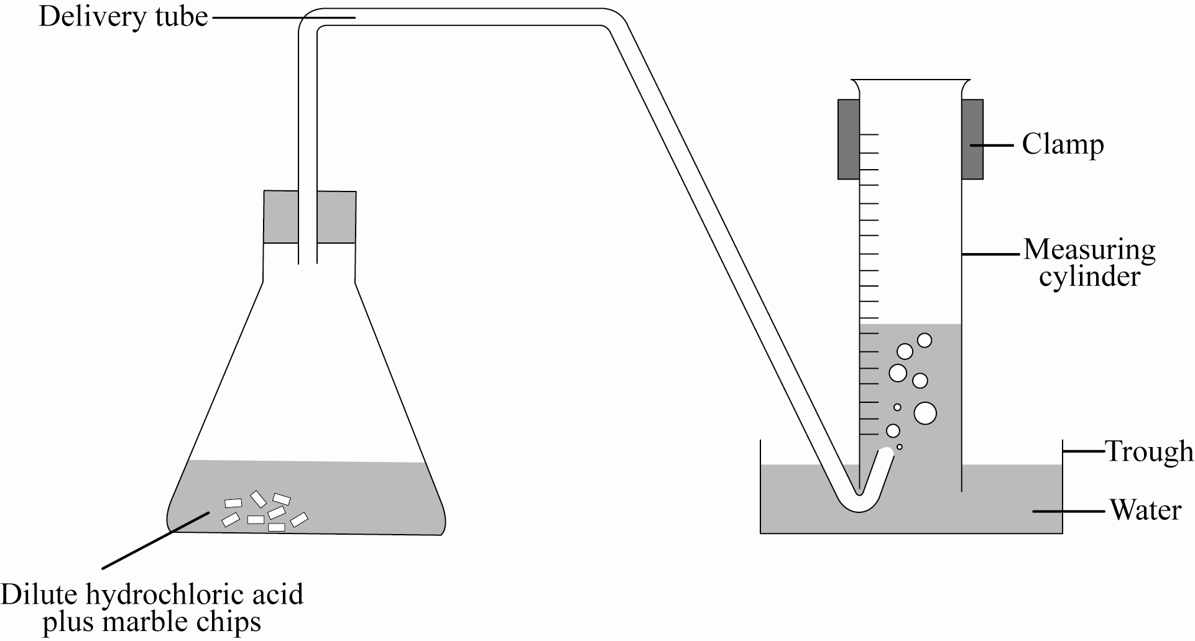  The experiment is repeated but this time the same mass of marble chips is crushed into a powder before it is added to the flask.  Discuss the effect on the reaction rate of using powdered marble with hydrochloric acid compared with using marble chips. In your answer, you should:  - compare the rates of reaction  - explain the differences in the reaction rate by discussing how crushing the marble chips affects the number of particle collisions. | Language Features  Science Vocab  (what science terms are needed in the answer?)  Science phrases (which specify the subject and details of the idea/ concept(s))  Linking words & phrases  (what linking words can be useful when comparing?)
Your task is to address the underlined sections. Then attempt the question
In class Strategy 2 – Plan an answer using word targets before diving in

Word Targets – Aiming for good answers  Could  Question  Must  Should | Answer
In class Strategy 3– Use your school acronym to write answer
This is a whole question from a level 1 genetics paper last year  Make sure your answer is DED SEXY  This means in the whole answer you  Describe  Explain and  Discuss  In each paragraph you have  Statement  Example  eXplanation  Your ideas  In this example you will need a couple of paragraphs at least for parts a and b.  Write four paragraphs, don’t repeat ideas | (a)Explain the relationships between DNA, chromosomes and genes.  (b) Explain how the relationships in your answer to (a) lead to different characteristics and how this contributes to genetic variation.
In class Strategy 4 – Connecting words
Have a good look at the connecting language below, this graphic comes from http://jamieleeclark85.wordpress.com/ other good ideas there

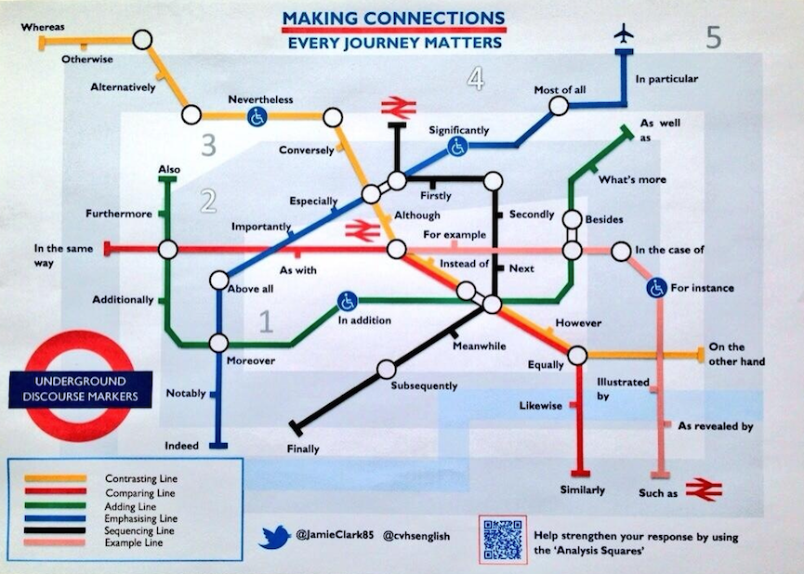
Now complete paragraphs about the following science ideas using connecting words from above
A contrasting paragraph about acids and bases | A comparing paragraph about meiosis and mitosis | An adding paragraph about pressure
An emphasizing paragraph about rates of reaction | A sequencing paragraph about variation | An example paragraph about balanced forces
Alternatively write six paragraphs on one topic, e.g. Meiosis and mitosis, Acids and bases or Balanced and unbalanced forces
A contrasting paragraph | A comparing paragraph | An adding paragraph
An emphasizing paragraph | A sequencing paragraph | An example paragraph
In class Strategy 5 Talking to the Answer. Similar to talking to the text, analyse exemplar answers and annotate them with comments and questions

Possible questions or comments
What science vocabulary is used?
What connecting words are used?
What types of paragraphs are they?
What else could you add?
What surprised you?
What will you not do that they did?
What will you definitely do that they did?
Pick out a describe section, an explain section and a discussion section if you can
What grade do you think they achieved

The exemplar below is Achieved, I have had problems producing good electronic copies but if you download exemplars from the last two years you should be able to pick out suitable answers. The second sheet is an answer from a mark schedule 2013 Genetics
http://www.nzqa.govt.nz/ncea/assessment/view-detailed.do?standardNumber=90940
http://www.nzqa.govt.nz/ncea/assessment/search.do?query=90944&view=all&level=01
http://www.nzqa.govt.nz/ncea/assessment/search.do?query=90948&view=all&level=01
These are the links for the three Science externals to find exemplars and schedules

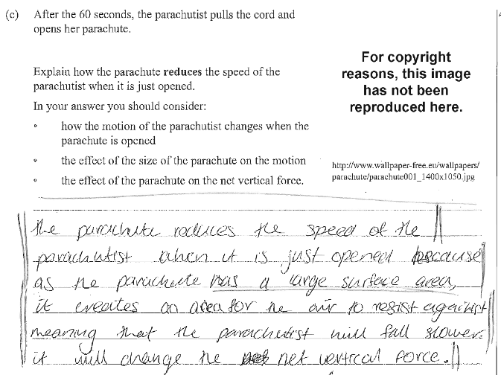

Question explain the relationship between chromosomes, genes, alleles, phenotype, genotype, and the molecule DNA

Chromosomes are made up of DNA. DNA is a large molecule that is coiled into a double helix (twisted ladder structure). It is responsible for determining the phenotype of an organism. Along this molecule are bases. These bases pair up; A always pairs with T, and G with C.
A sequence of bases which codes for a particular trait (eg, eye colour) is called a gene.

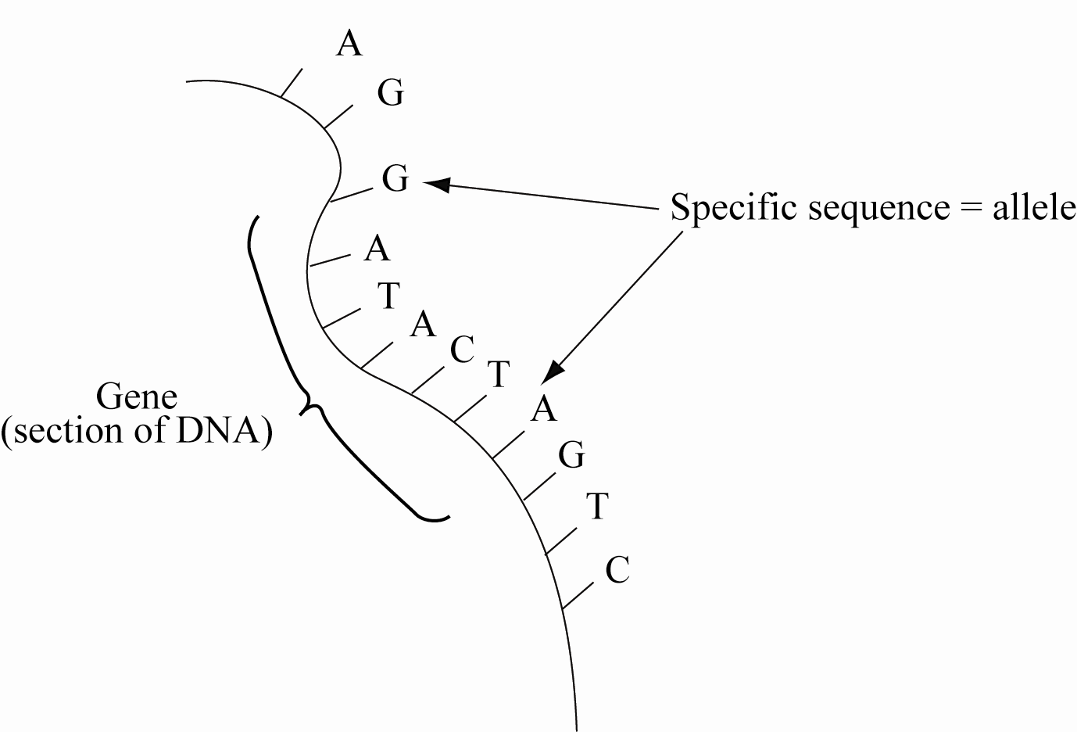

The different versions of each gene are called alleles, and these show the different variations of each characteristic, eg brown / blue eyes. Because chromosomes come in pairs for each trait, there will be two possible alleles. These different versions of genes (alleles) occur as the DNA base sequence is different.
This combination of alleles for each trait is called the genotype; this can be any combination of two of the available alleles. The genotype determines the phenotype (the physical appearance) of the organism. Whichever alleles are present may be expressed. Dominant alleles (B) will be expressed over recessive alleles (b).
In class Strategy 6 Double Bubble, planning to compare and contrast, then write an answer

Double Bubble

Different Because Similar because Different because

Phenotype
Genotype

Different Because Similar because Different because

Base
Acid

In class Strategy 7 A picture says a thousand words…………but does it ask questions?

Look at the pictures below

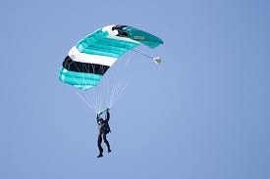 | 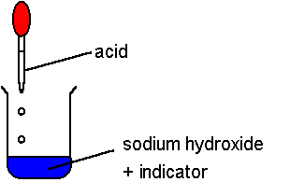 | 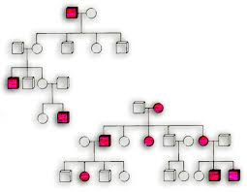

Task 1
If this is the picture in an exam question which paper is it in and what knowledge is it likely to be testing?

Task 2
If this is part of the question what could the whole question be?
- Write 4 possible achieved questions
- Extend one of the questions so it is a merit and excellence question

Task 3
Can you answer other peoples questions

In class Strategy 8 Poetry in Motion
This is a thinking exercise in which pupils condense their knowledge into a 5 line poem of few words

Rates of reactions
Line 1 is 1 word and describes the topic
Line 2 is 2 words and explains what you need to understand the topic
Line 3 is 3 words and
Line 4 is 4 words and describes what the first line means to writer
Line 5 is 5 words and gives an example

For example

Rates
Collision theory
Concentration, Temperature, Surface
Reactions fast or slow
High temperature increases reaction rate
Try genes, pressure, acid, indicator, friction, variation, gravitational potential energy,gamete

Then students compare their poems with their group and justify important keywords that the have included and others haven’t

Student sheets 1 This is an example of what I gave students last year to help them revise
Planning your revision
Think about how many credits you are revising for in each subject, as an absolute minimum you should be doing two half hour revision slots per day until prize giving. After that at least 3 one hour slots a day leading up to exams. Use these basics to fill in a revision timetable

Using Success Criteria to Help You Revise

Step 1 Complete Success Criteria for each standard, look at the standard and work out what you need to be able to do

Step 2 Use your practice exam papers and review sheet to help you decide which success criteria you need to work on

Step 3 Use the Define, Answer, Example, Extras model and your notes to write good in depth answers to your success criteria.

Step 4 Fill any gaps in your knowledge

Using revision summaries to Help you Revise

Step 1 Make a topic summary for one section of the science course
This could be a mind map, cards or a concept map. Use your notes, lots of diagrams and colour.
Step 2 Splurge everything you know about this topic onto a blank piece of paper. Then use your summary to fill in the gaps in a different colour (splurging is filling up a blank sheet with everything you know about the topic)
Step 3 Past paper questions then mark them
Step 4 Study any gaps and improve your understanding

Start again with a new Splurge on this topic or the next.
Student sheet 2This is a revision timetable I gave out last year, make one for them if you want them to have one
Revision plan 2012 Term 3
Week | Mon | Tues | Weds | Thurs | Fri | Sat | Sun
2 | 23 | 24 | 25 | 26 | 27 | 28 | 29
3 | 30 | 31 | 1 | 2 | 3 | 4 | 5
4 | 6 | 7 | 8 | 9 | 10 | 11 | 12
5 | 13 | 14 | 15 | 16 | 17 | 18 | 19
6 | 20 | 21 | 22 | 23 | 24 | 25 | 26
7 | 27 | 28 | 29 | 30 | 31 | 1 | 2
8 | 10 | 11 | 12 | 13 | 14 | 15 | 16
9 | 17 | 18 | 19  SENIOR EXAMS BEGIN | 20 | 21 | 22 | 23
10 | 24 | 25 | 26 | 27 | 28 End of term | 29 | 30
Student sheet 3 Another Teachers
How to Study guide (Gerald Walker
From Mahurangi College)

Achievement outcomes from www.studyit.org.nz
Get Learning Outcomes from your teacher.

Use your Textbook
Go On-line

Check your notes!!!
Ask your Teacher

Question & Answer cards

- Put question on one side and the answer on the other.
- Test yourself regularly.
Make Your Own Podcast
Then you can listen to your own voice!
Summary Notes

- Make brief outlines of the key ideas.
- Use mnemonics like CAGE SHELK

Concept or Mind Map
See ideas at http://www.enchantedlearning.com/graphicorganizers/

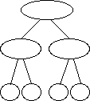

Make a Poster
- Flow chart of a process.
- Draw a process in action.
- Make a cartoon of the process.
- Illustrate all the factors important to this concept.

Okay then smarty-pants! Try some previous years papers or Problems from a revision book.

